Title : Ocean Rescue

Names: Sara Alashqar, Ka’Tiera Boone, Haya Alghazouli, Jaeda Williams.

Instructors : Cengiz Gunay and Rahaf Barakat.

**TAP (Technology Ambassador Program)**

Abstract : “Ocean Rescue“ is a video game created by Georgia Gwinnett College (GGC) Information Technology students the four of us involved with GGC’s Technology Ambassador’s Program which will result in an increased interest and passion in Information Technology programs and technology among middle school, high school, and college students, particularly underrepresented groups. Our goal was to appeal to students ranging from middle school to college, “Ocean rescue” is a multi-player game that is aesthetically reminiscent of Pac-man. And challenges players to collect points, defeat enemies by escaping, and obtain a high score. It also introduces a “Lives” counter, and decreases the lives when attacked. This game was designed using Scratch, while “Makey Makey” will be responsible for the game controls. “Ocean rescue” not only allows players to play the game by using the arrow on the keyboard it also allows them to play with their feet to control the fishes inside the game, using “Makey Makey”. This feature provides a fun, engaging way for students to interact with computer language and Scratch, understand how code affects software, and to develop an interest in computer programming, as well as teaching them about if, then statements, forever loops, Boolean, and iteration through activities such as score manipulation.

**Introduction :**

  TAP stands for the Technology Ambassador Program that was invented to develop educational technology directed towards non-IT students and students K-12. TAP has so many goals that are so beneficial for students who choose to take this class. To name a few, TAP wants to increase the number of students who persist and pursue an IT major or minor, it also wants to develop leadership skills, communication, and technical skills, and it wants to provide students-lead, student driven tech support for GGC outreach initiatives and for intro STEM courses, the last but not least is to reduce the gender gap since women make up only 28% of the workforce in technology. ­

Being members of TAP has become one of the best experiences in our lives because not only were we able to learn so many things that we all did not know before but also it triggered the creativity inside each one of us. We were allowed to pick our own project that we felt comfortable working on and had the chance to see how it turned out. One of the biggest things that got us so motivated in this class is team work we were separated in teams of four which had helped us develop our communication and teamwork skills. This class was so unique because we learned a lot from it all while having so much fun throughout the semester.

­­­

**TECHNOLOGIES WERE USED AND WHAT WE TRING TO TEACH**

Our team created a game name Ocean Rescue which is similar to Paceman game by using scratch and makey makey, scratch is an online programming website that allows the user to do drag and drop basic coding to create their game, however makey makey was the extension that we added to the game to make it more interesting, makey makey is a USB device that you can connect it to your game and plug it into your computer to make any daily objects used instead of the keyboard keys. Through our game the goal was to teach, if then statements, forever loop, manipulating variables and iteration with a score counter.

**TAP EXPO EVENT**

We set the game and the makey makey and shared our game with students who joined us and were interested in this TAP event.

For the makey makey we created a board that involve four arrows which each arrow represent a direction.

**TAP WORKSHOPS**

We created a PowerPoint slides explaining the basic codes that we used to create Ocean Rescue, we were able teach the if then statements, forever loop, manipulating variables, and iteration with a score counter. Then we followed the steps that were mentioned in the PowerPoint slides and re-created the game with them. After the students created their game, we let them try our game using the makey makey board that we made. And that was extremely fun. There also was a pre and post survey for the students to take and to see if they actually learned from us.

**SYMPOSIUM**

In our symposium event we were able to show the result of the pre and post survey and our achievement and what we were able to teach, also what was some challenges that faced us while making the game, what was the ups and downs and all these information.

# **Results and Discussion:**

Our theory was to figure out can we teach coding with a drag and drop game? The game “Ocean Rescue” provided results that confirmed our workshop was able to teach participants how to make their own game. As shown in Figure 1a, we wanted to know if the participants learned what an “if-else statement” is and forty-three students out of fifty knew what an if-else statement was. The workshop was able to teach certain variables that use “if-else statements” such as creating characters which helped participants to retain knowledge. In Figure 1b, we wanted to test if participants learned what an “loop” is and forty out of fifty-one students was able to correctly answer the question. In the workshop, we taught the participants how to use a “forever loop” to make their characters move. The next question was to test if the participants learned “what determines if the game is over?” and found that forty-nine out of fifty-one participants how to implement this variable. Lastly, we asked our participants how difficult was it to learn this material and we found that thirty-eight out of fifty-one participants found the material easy to learn. Our workshop was able to determine our theory which was proved successful.

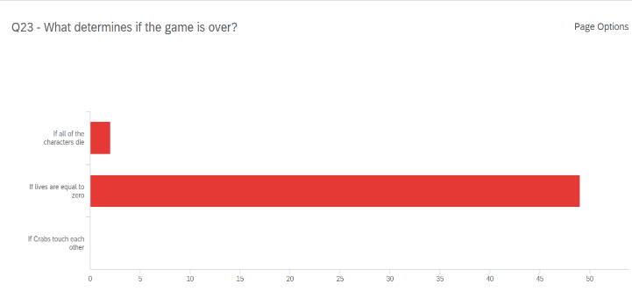

Figure 1c

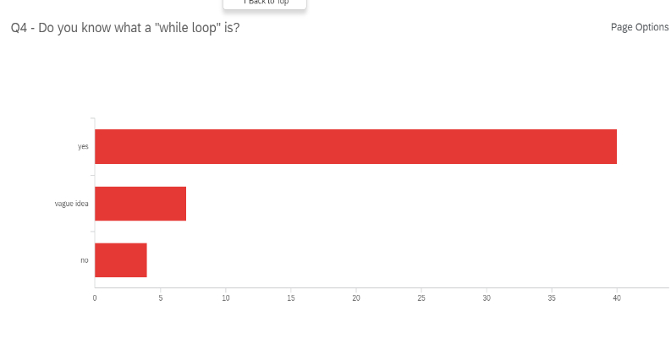

Figure 1b

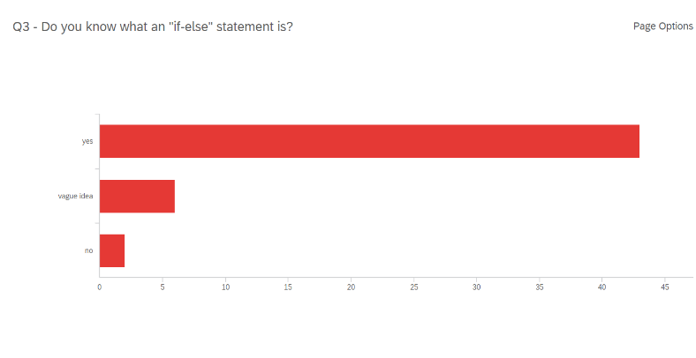

Figure 1a

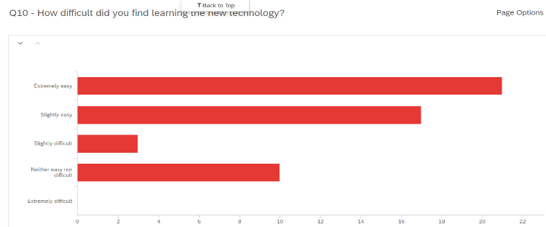

Figure 1d

**Conclusion and Discussion:**

In this research project, we explored student success in understanding fundamental concepts through coding their own individual game. There was much success in the practical applications of these concepts, based on the pre and post assessments given to each student prior to and immediately after the workshop. We saw that many of the students did considerably better after our workshop than they had beforehand. Another goal we had was to spark an interest amongst our audiences to pursue jobs in ITEC related fields as well. In our TAP expo, we saw students were highly interested in playing the game we created and were also intrigued by the Makey Makey board being implemented in the game play as well. Our group had four workshops, each apart of ITEC 1001, all of which are an introductory course to coding and programing. We realized that the students would not know much about coding; However, we noticed that in each class, there were a small handful of students who had been pre-exposed to coding and also the platform scratch. During the workshops, we saw that those students took the initiative to include their own unique elements in their personal games which added a very interesting flare to the workshop. For the other students who were not pre-exposed, we also saw just how creative they were able to make their games. Very few students had trouble keeping up, and very few made to many mistakes. The only issue we did take note of was when we reached certain parts of the code, some students would mistakenly create a nested if, then statement, as opposed to creating individual if, then statements when necessary. The hardest part of the project might have been leading the online workshops, as opposed to the in-person, simply because it was very difficult to gauge exactly what the student’s pace was. In summation, we were able to meet our goals within our classes, and our results from the assessments and surveys reflected increased understanding and also, an increase in general interest in both learning and using new technology.